Project Planning Phase
Project Planning Template (Product Backlog, Sprint Planning, Stories, Story points)

Date | 15 February 2025
Team ID | LTVIP2026TMIDS66363
Project Name | Asset Management Portal
Maximum Marks | 5 Marks

Product Backlog, Sprint Schedule, and Estimation (4 Marks)
Use the below template to create product backlog and sprint schedule
Sprint | Functional Requirement (Epic) | User Story Number | User Story / Task | Story Points | Priority | Team Members
Sprint-1 | Registration | USN-1 | As a user, I can register for the application by entering my email, password, and confirming my password. | 2 | High | Team
Sprint-1 | Registration | USN-2 | As a user, I will receive confirmation email once I have registered for the application | 1 | High | Team
Sprint-2 | Login | USN-3 | As a user, I can register for the application through Facebook | 2 | Low | Team
Sprint-1 | Dashboard | USN-4 | As a user, I can register for the application through Gmail | 2 | Medium | Team
Sprint-1 | Login | USN-5 | As a user, I can log into the application by entering email & password | 1 | High | Team

Project Tracker, Velocity & Burndown Chart: (4 Marks)
Sprint | Total Story Points | Duration | Sprint Start Date | Sprint End Date (Planned) | Story Points Completed (as on Planned End Date) | Sprint Release Date (Actual)
Sprint-1 | 20 | 6 Days | 24 Oct 2022 | 29 Oct 2022 | 20 | 29 Oct 2022
Sprint-2 | 20 | 6 Days | 31 Oct 2022 | 05 Nov 2022 | 20 | 13 Mar 2026
Sprint-3 | 20 | 6 Days | 07 Nov 2022 | 12 Nov 2022 | 20 | 20 Mar 2026
Sprint-4 | 20 | 6 Days | 14 Nov 2022 | 19 Nov 2022 | 20 | 27 Mar 2026

Velocity (Management Asset Portal)
Imagine we have a 10-day sprint duration for the Management Asset Portal, and the velocity of the team is 20 (points per sprint). Let’s calculate the team’s average velocity (AV) per iteration unit (story points per day).
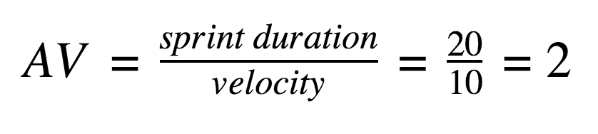

Burndown Chart:
A burndown chart is a visual representation that shows the remaining work against time in a project. It is commonly used in agile development methods like Scrum, but it can also be applied to projects such as a Management Asset Portal to track progress, monitor task completion, and ensure the project stays on schedule.
https://www.visual-paradigm.com/scrum/scrum-burndown-chart/
https://www.atlassian.com/agile/tutorials/burndown-charts

Reference:
https://www.atlassian.com/agile/project-management
https://www.atlassian.com/agile/tutorials/how-to-do-scrum-with-jira-software
https://www.atlassian.com/agile/tutorials/epics
https://www.atlassian.com/agile/tutorials/sprints
https://www.atlassian.com/agile/project-management/estimation
https://www.atlassian.com/agile/tutorials/burndown-charts

